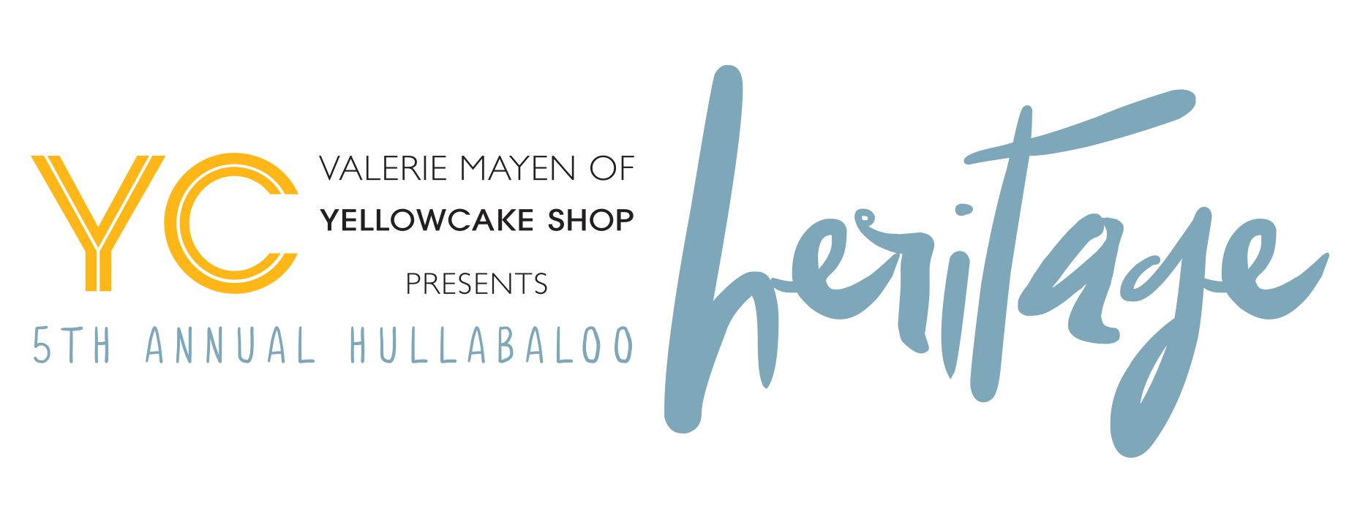

Food/Beverage Commitment Form

Establishment Name: _____________________________________________________

Contact Person: ________________________________________________________

Address: ______________________________________________________________

_______________________________________________________________

Cell: ____________________________ Email: _______________________________

Pick up on 11/5 at (address):________________________________________________

Deliver to The Nash, 3563 E. 80th on 11/5 by 4:00pm: ___________________________

We will be donating a minimum of 500 bites on disposable platters of:______________

______________________________________________________________________

______________________________________________________________________

Hullabaloo Location: The Nash * 3563 E. 80th Street, Cleveland, OH 44105
Please mail this sponsorship form to Hullabaloo * 22420 Calverton Road * Shaker Hts * 44122
Questions? Contact Char Glatley, Hullabaloo Event Consultant at
216.288.6388 or email form to char@charglatley.com

HULLABALOO 2016

For more information, please visit DoYouBaloo.com.

